The UK Government’s Gift Aid scheme means Charities can reclaim tax on all gifts. To do this we require you to complete the form below. How we benefit: we can reclaim 25p of tax on every £1 you give. Gift Aid will be used to funds Earth Community Trust’s general work.

Gift Aid Declaration

Dear Earth Community Trust (charity no. 1143660) please treat my gift of

£ __________________ on (enter date here) __________________

as a Gift Aid donation.

Please tick to apply:

- Please treat all gifts that I make today and in the future as Gift Aid donations.

- Please treat all gifts that I have made in the past 6 years to the ECT and all future gifts that I make from the date of this declaration as Gift Aid donations.

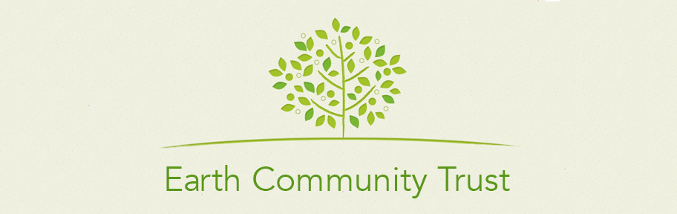
Please note: You must pay an amount of Income Tax and/or Capital Gains Tax for each tax year (6 April to 5 April) that is at least equal to the amount of tax that the charity will reclaim on your gifts for that tax year.

Donor’s details

Title

Name

Home address

Postcode

Date Signature

Please notify us if you want to cancel this declaration, change your name or address or no longer pay sufficient tax on your income and/or capital gains.

If you pay Income Tax at the higher or additional rate and want to receive the additional tax relief due to you, you must include all your Gift Aid donations on your Self-Assessment tax return or ask HM Revenue and Customs to adjust your tax code.

Please return this form to office@earthcommunitytrust.org

